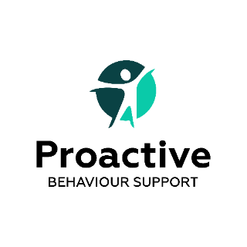
Referral Form for behaviour support
Date of referral
Participant name
Date of birth
Does participant identify as Aboriginal or Torres Strait Islander?
Address
Type of residence? e.g. SIL, SRF
Name and phone nbr of accommodation manager
Guardian (who will be signing the service agreement if it is not the participant)
Guardian’s email address
Guardian’s phone number
Guardian’s relationship to participant
Is the participant verbal?
Any communication difficulties?
NDIS number
NDIS plan start date
NDIS plan end date
How is the plan managed? | Agency managed / Plan managed
Name of Plan manager
Plan Manager Email
*Support Coordinator
*Support Coordinator Email and phone number
Funding for Behaviour Supports in plan: (This information MUST be provided before we can proceed with accepting the referral) | Improved Relationships (CB) under Capacity Building  Specialist Behaviour Intervention Support  Total Hours _____ $  Behaviour Management Training  Total Hours_____ $
Improved Daily Living funding?
Has participant had a previous behaviour support plan?

Please provide detail about the behaviours of concern.
Diagnosis/ Disability (including mental health diagnosis)

Consent for referral

Yes – this referral has been discussed with the participant and / or their guardian, and they understand and agree with the referral being made and providing collateral information to Proactive Behaviour Support.

Name: _________________________________

Signature: ______________________________

Thank you for your referral to Proactive Behaviour Support. We will contact you within 24 hours.

NDIS Registration ID. 4-G 111233

*Any questions please ring Amanda Bodycote, Director on 0412867532 or email on amanda@proactivebs.com.au

